# Vishwakarma Government Engineering College

**Project Report On:**

## “Expenses Tracker System”

Design Engineering II-A

BE (V)

CE Department

Academic Year

(2019-20)

Submitted by: Group:

|  |  |  |
| --- | --- | --- |
| **Sr.** | **Name of Student** | **Enrolment No.** |
| 1 | Ajani Jyot | 180170107001 |
| 2 | Asodariya Siddharth | 180170107003 |
| 3 | Gajjar Daksh | 180170107031 |
| 4 | Goyani Kevalkumar | 180170107034 |

Prof. Bhumika Panchal

(Faculty Guide)

Prof. M.T.Savaliya

(Head of Department)

Academic Year (2019-2020)

|  |  |  |  |
| --- | --- | --- | --- |
|  |  |  |  |

**OBSERVATION**:

**Observation 1:**

Expenses tracking is the process and a small feature behind how we can reduce our expenses. Money saving is always desirable and also applicable.

## DESIGN THINKING CANVAS

* 1. **AEIOU canvas**

This is the very first canvas of our design engineering subject. After thinking on different domains, we have selected one domain and have done the observations after completing our observation we have divided complete observation in 5 parts into AEIOU i.e. is A for Activity, E for Environment, I for interaction, O for object, U for Users.

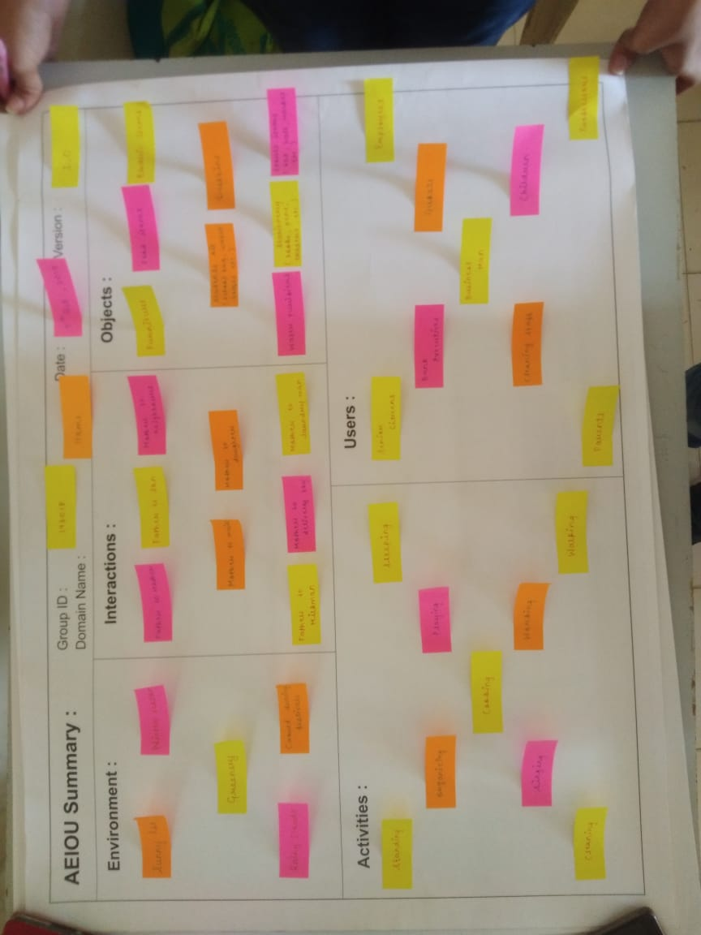

Figure 3 AEIOU Canvas

With the help of this canvas we have make the partition of our complete observation through which we can easily identify the key points of our observation from which we can know about the problems which are faced.

### Activity:

In this part we have included all the activities which was being performed by the different users, people, etc. during our observation.

The activity includes: -

* Conversation with users
* Meter checking
* Get reviews
* Sensor checking

### Environment:

This section contains different factors which shows different situation

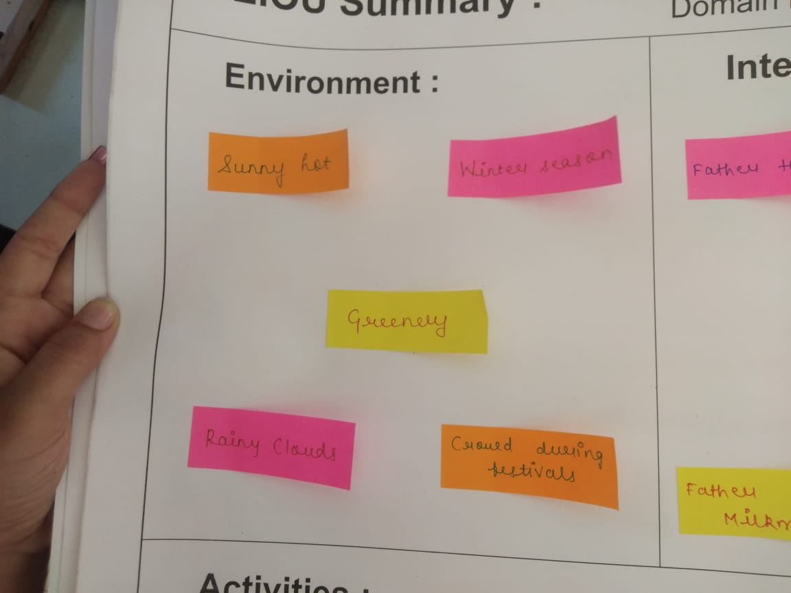

Figure 5. Environment

Key points of environment are as follow

* + - * Sunny hot
      * Winters Season
      * Greenery
      * Rainy Clouds

### Interaction:

This includes the conversation which we have done with patients, doctors, staff etc.

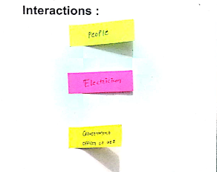

Figure 6. Interaction

Key points of interactions are as follow

* + - * Mother to Father
      * Mother to son
      * Father to son
      * Father to neighbor

### Objects:

This section is completely filled up with all the non-living things. Through this section we could also

know many things.

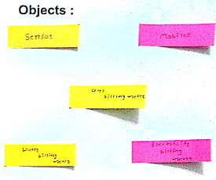

Figure 7. Objects

Key points of objects are as follow.

* + - * Smart Phone
      * Electric item
      * Stationary

### Users:

Users are the people who are involved during the observation. They are the people who have played the role.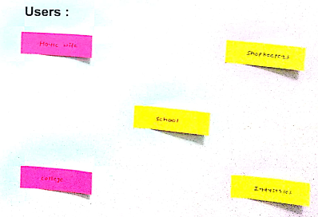

Figure 8. User

Key points of users are as follow

* Citizens
* Workers
* Employees
* Housewives

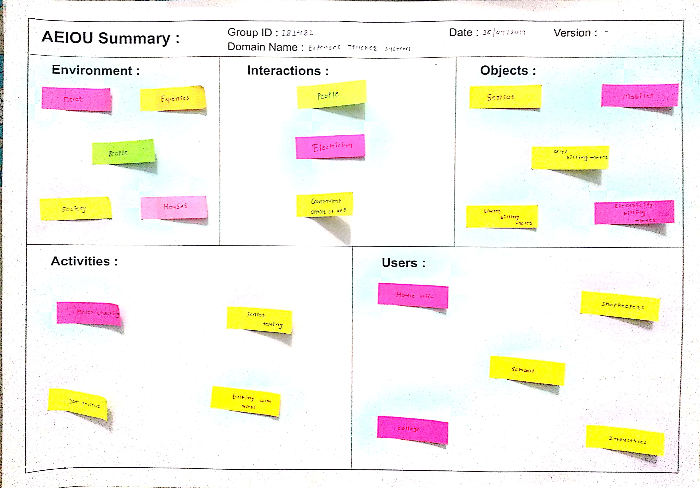

### Mind Mapping Canvas

As we know that for remembering & keeping the points in mind graphical or diagrammatic representation is the best way. So in the Design Engineering for representation of complete observation Mind Mapping Canvas is used.

Mind Mapping is the diagrammatical representation of complete Observation.

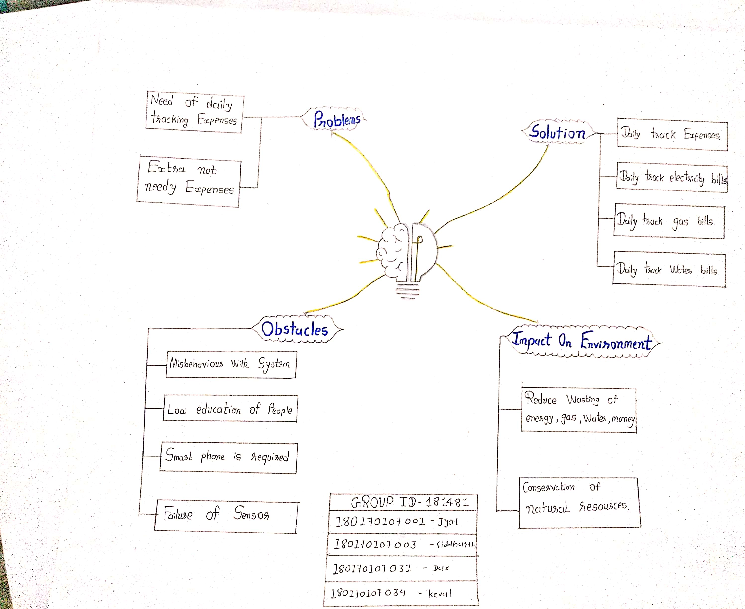

Figure 9. Mind Mapping

Here in the above mind map, we have divided it into 4 branches.

* + - Purpose
    - Advantages
    - Uses

### Empathy Mapping Canvas

Empathy means to feel what the others feel. Empathy mapping canvas helps as to experience, feel and understand another person’s condition, situation & emotions with the help of observation. Empathy Mapping Canvas is the evolution of problem, which are faced by people, by experiencing it with faced by us.

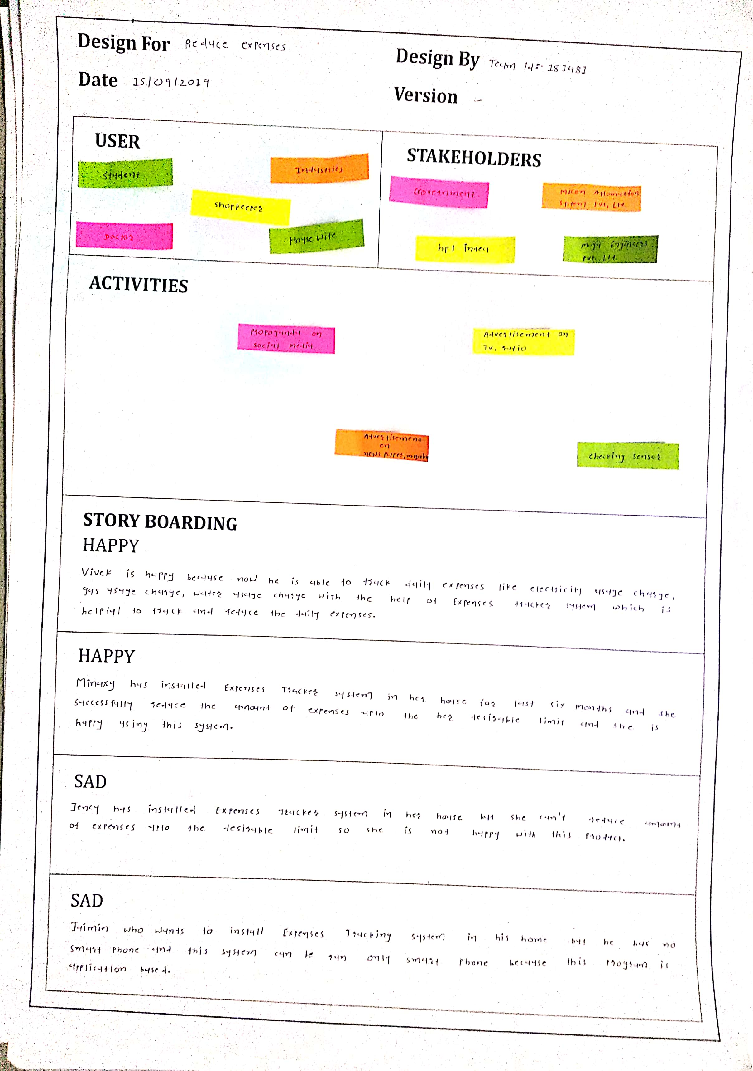

Fig. 10 Empathy Mapping Canvas

Empathy Mapping Canvas have 4 components:

* + - * User
      * Stakeholders
      * Activities
      * Story

### User:

Users are the people who play the key role in whole observation.

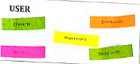

Fig. 11 User

Key Points of Users are as follow

* shopkeepers
* House wives
* Industries
* Employees

### Stakeholder

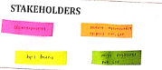

Fig.12 Stakeholder

Key points of Stakeholders are as follow

* Network Provider
* Device Manufacturer
* Platform Provider

### Activities:

This section consist of the activity which people experiencing & seeing that activates how & which activity have been explained by us.

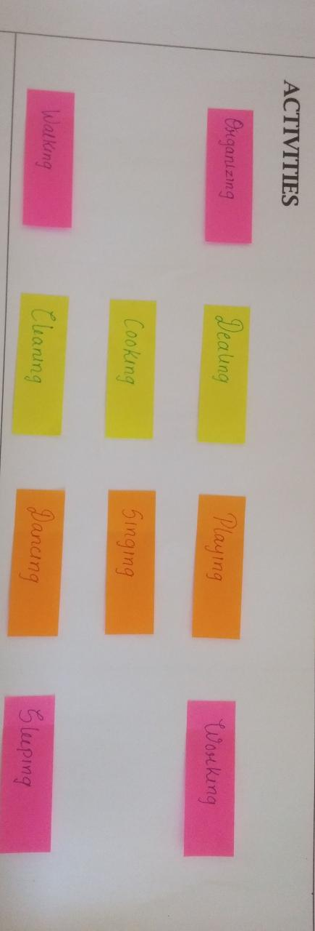

Figure 13. Activites canvas Key points of Activity are as follow:

* Wasting money
* Uses extra electricity, gas and water
* Working

### Story:

This component can also be said as the heart of the empathy mapping canvas

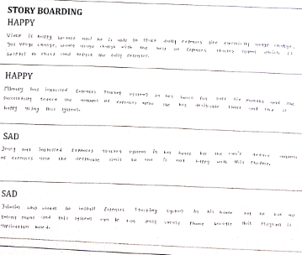

Figure 14. Story

### Happy story: 1

### Vivek is happy because now he is able to track daily expenses like electricity usage charge, gas usage charge, water usage charge with the help of expenses tracker system which is useful to track and reduce the daily expenses.

**Happy story: 2**

Minaxi has installed expenses tracker system in her house for last six months and she successfully reduce the amount of expenses up to her desirable limit and she is happy using this system.

**Sad story: 1**

Jency has installed this system in her house but she can’t reduce amount of expenses up to desirable limit so she is not happy with this system.

**Sad story: 2**

Jaimin who wants to install this system in his factory but he hasn’t knowledge of how to use smartphone and this system works only on smartphones.

* 1. **Ideation Canvas**

Ideation canvas helps us in doing work creatively. Because ideation canvas develops the new

Thoughts and idea in mind through which we can know about the problems and what should be the situation for it.

Ideation canvas has 4 main parts:

* + - Users
    - Activity
    - Situation/location
    - Props/objects

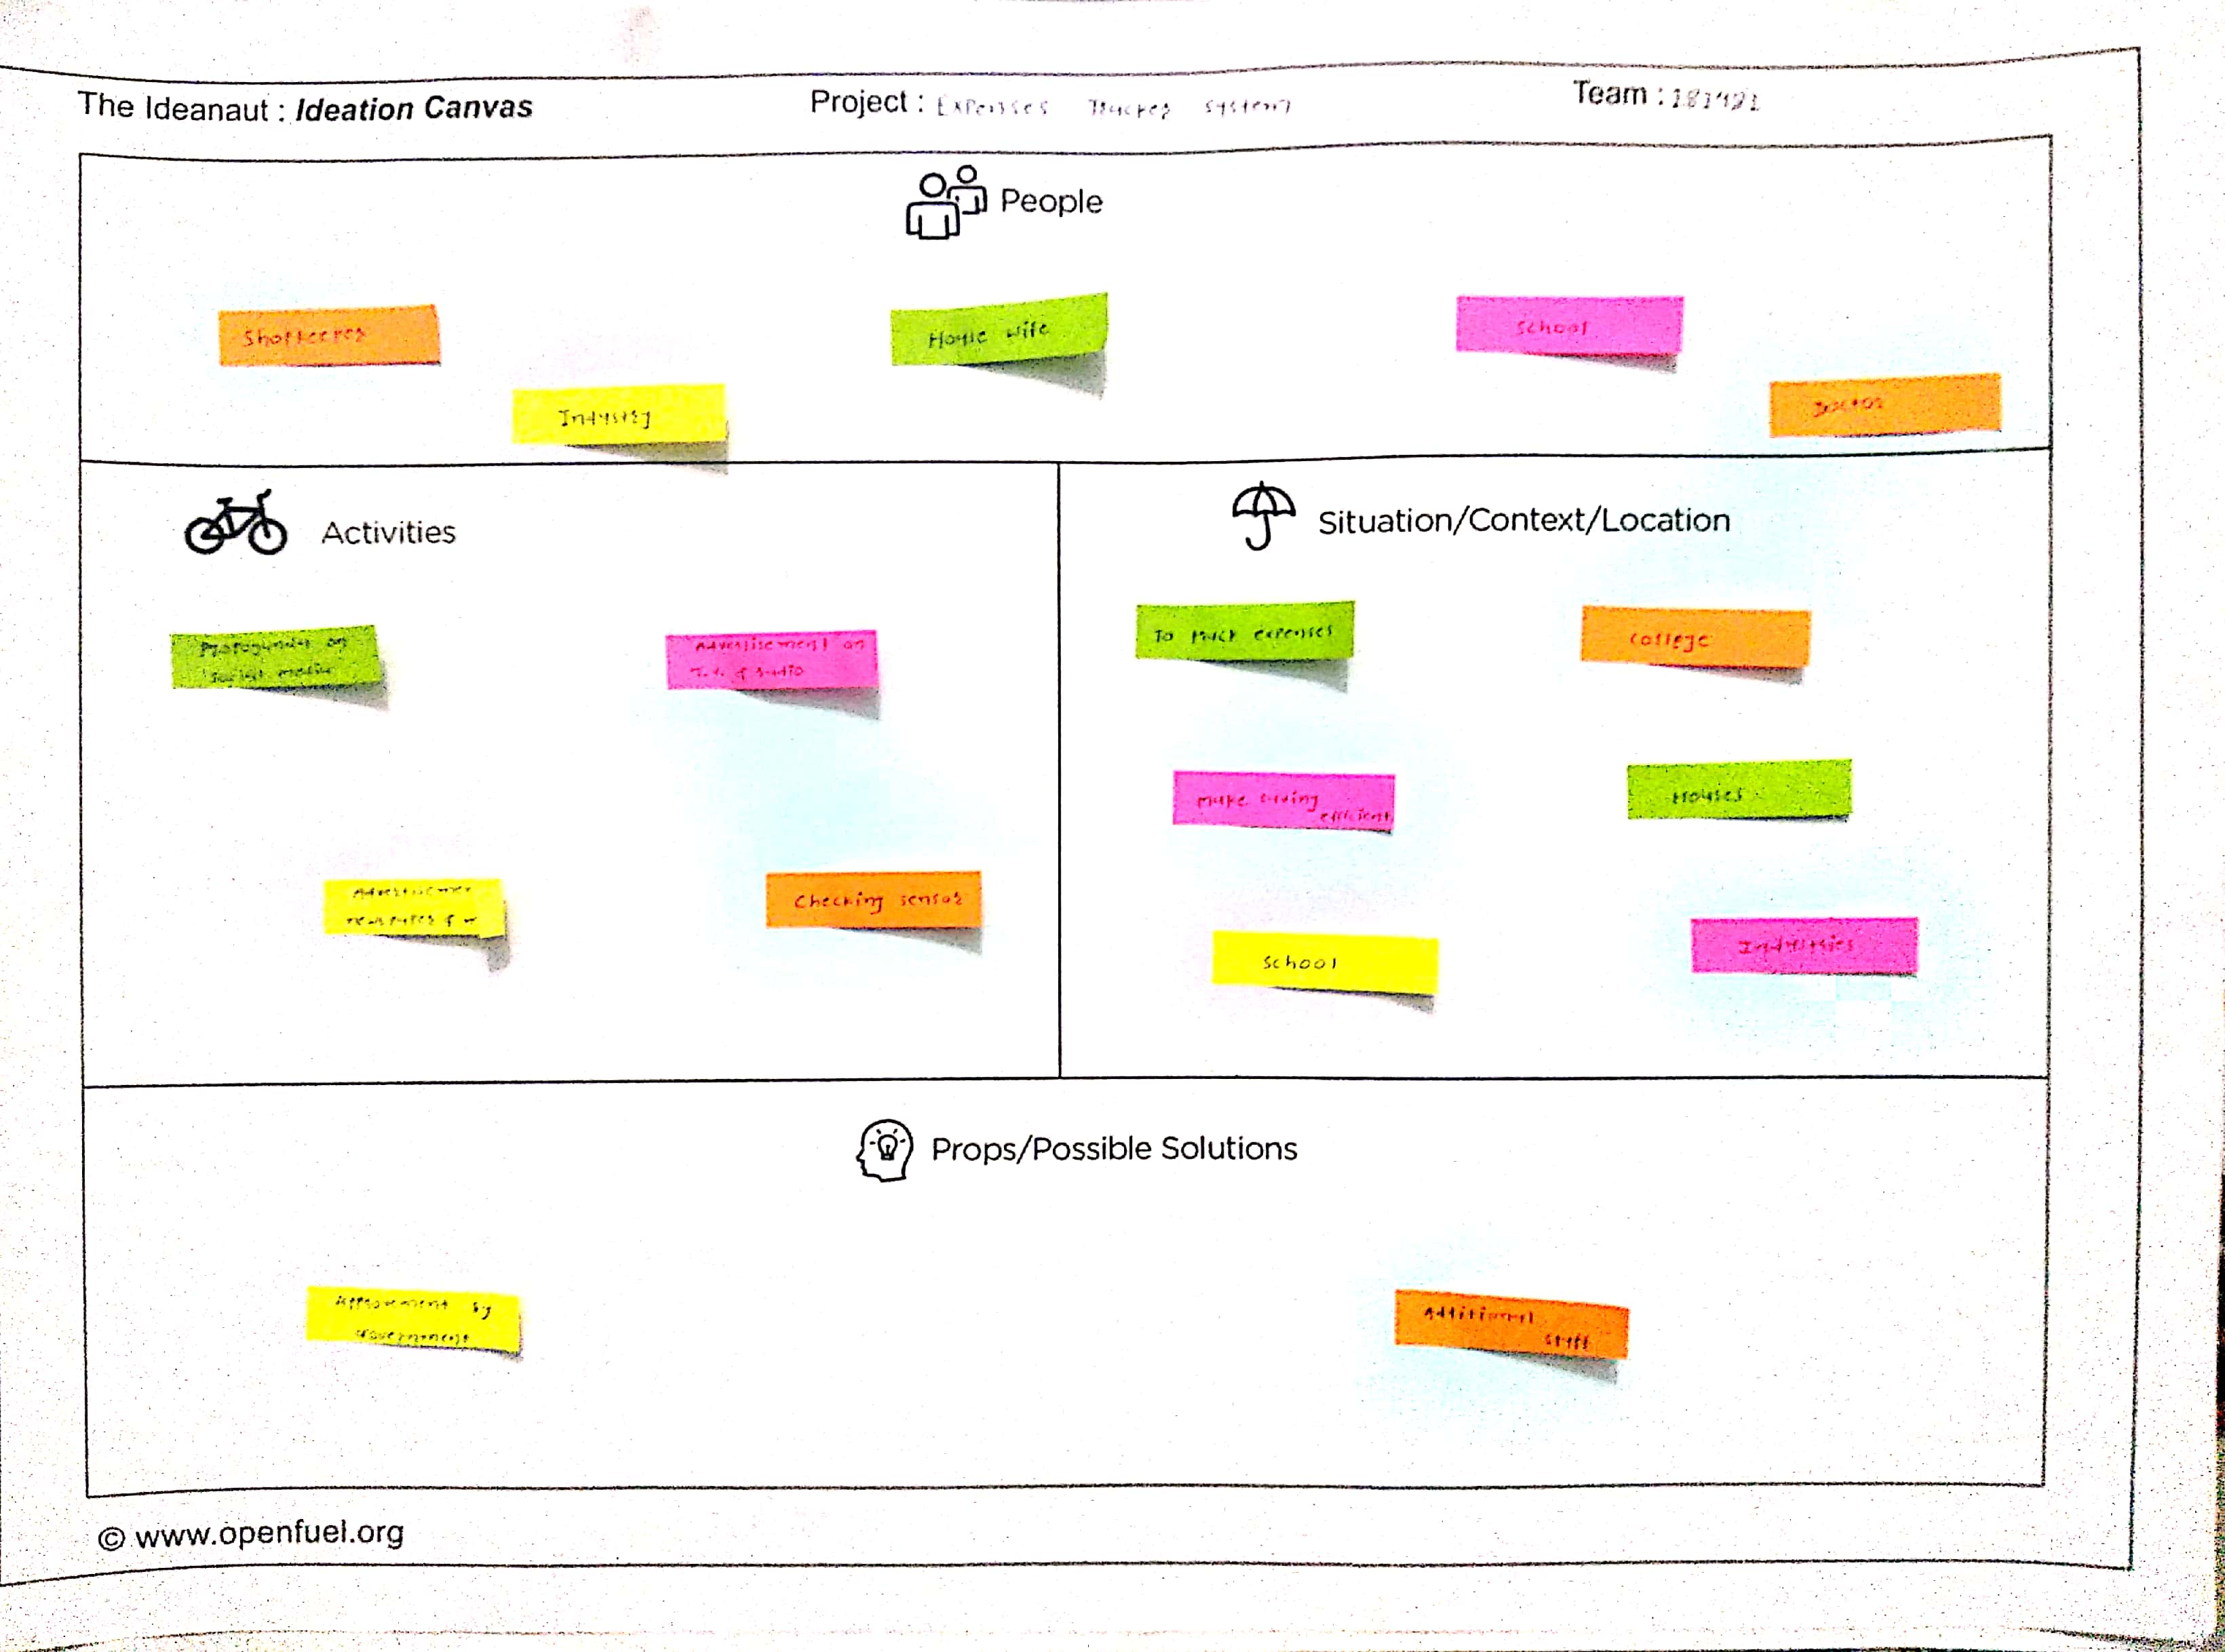

Figure 15. Ideation canvas

### Users:

Users are the people who play the key role in whole observation.

Key points of User are as follow

* + - Family Member
    - Employees
    - Industries
    - House wives

### Situation/context/location:

This content includes the situation in which the user uses this application.

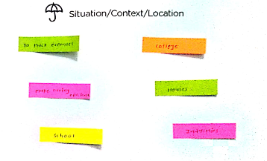

Figure 17. Situation/context/location

Key points of situation/context/location are as follows:

* + - Conservation of Electricity, Water, Gas
    - Controlling over expenses
    - Save money

### Props/possible solution:

In this content the possible solution that our application resolves are included.

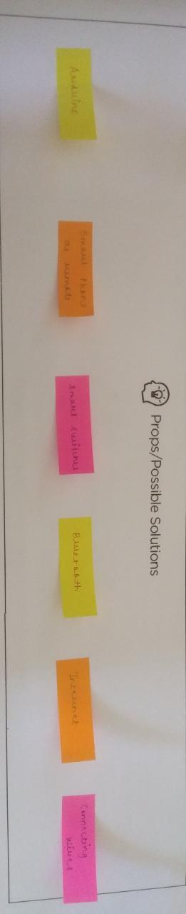

Figure 18. props/possible solution

Key points of props/possible solution are as follows:

* + - Ardunio
    - Smart Switches
    - Internet
    - Connecting Wire

### Activity:

In this part we have included all the activities which were being performed by the different users, people, etc. During our observation. The activity includes

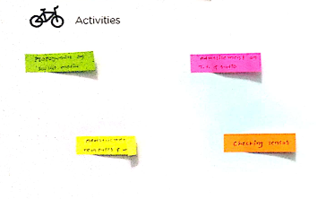

Figure 19. activities

Key points of activity are as follow:

* + - * Checking sensor
      * Advirtizement on T.V.
      * Propoganda on social media

### Product Development Canvas

Product Development Canvas concentrates on the solution of problems. In this canvas we describe about the product that is solution of entire problem. Solution includes features like people, purpose, product features and product component.

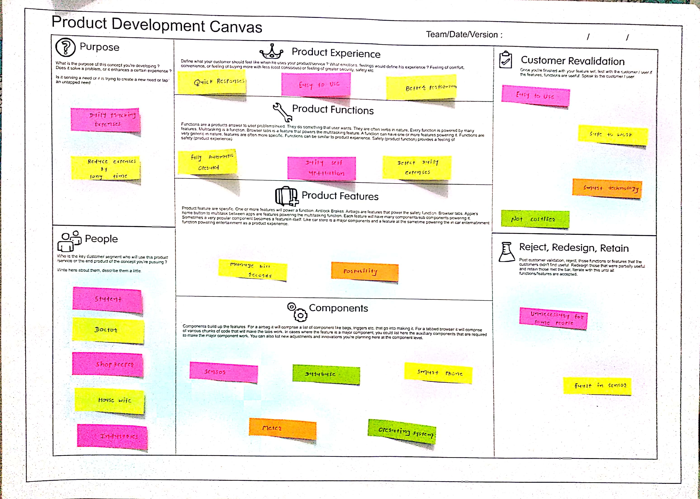

Figure 20. Product development canvas

### Purpose:

In this we describe the purpose of making this product. What is our main aim?

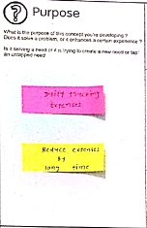

Figure 21. purpose

* Remote Controller
* Easy to use
* Technology Advancement
  + 1. People:

This portion contains the user who can use the product, to whom this product is useful

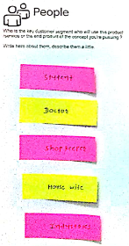

Figure 22. People

Key points of People are as follow: -

* + - * Physically Disabled
      * Guest
      * Family Member

### Product Components:

Figure 23. components

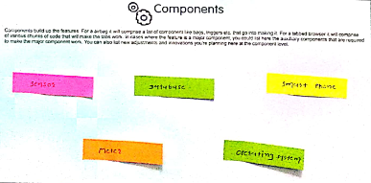

The components which are used in making the product are included in this.

* + - * Sensor
      * Smart phone
      * Circuit

### Product Featured: -

Features of the Product are included in this. What are the options, specifications of the Product are known as Product Features.

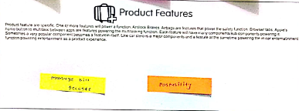

Figure 24 product feature

The product features are as follows:

* + - * Easy Operation
      * Low Cost

### Product Function:

### 

Product Function includes how product will be helpful other than it features.

Figure 25. Product function

They are as follows:

* + - * Automation
      * Advancement
      * Less Time Consumption

### Product Redesign/Reject:

### 

Fig. 26 Reject, Redesign, retain

In this section if there is any customer’s review related to redesign or related to rejection are included. The reviews we got are “excellent design” and “no chances of rejection”.

They are as follows:

* + - * People became lazy after using this product
      * Smart phone is necessary to operate this product
      * They Should know how to use smart phone

**LEARNING FROM DESIGN THINKING**

Design thinking is used to solve the problems and find the solution for those problems which is user friendly, and takes the world to the new step.

Design thinking helps us to imagine on reasoning, to explore the possibilities of what could be the, and to create desired outcomes that benefit the end user.

Through Design Engineering we have got opportunity to work on any domain from very beginning of our engineering. Due to this we got self- knowledge by working on particular one domain. By selecting the domain, we done the observation and on basis of that we have made different canvas from which we know about the problems and by using the skills of engineering we have made solutions for it.

By designing AEIOU CANVAS we have divided our whole observation in 5 parts activity, environment, interaction, objects and user. From this canvas we could easily identify particular object, person, activities performed.

After the AEIOU CANVAS we prepared the graphical view of observation which is named MIND MAPPING CANVAS. From this canvas we can easily imagine the complete observation which we have done. We can recall the observation easily.

Next comes, EMAPTHY MAPPING CANVAS this canvas describes the problems which people have faced. From this canvas we learnt what are the difficulties faced by the people. The main part of this Canvas is story. Through which we experience the problems.

After that, comes IDEATION CANVAS through ideation we can find the problems. It is divided into four parts user, situation, props and activates. By taking one pint from each point and by combing and making a

sentence it mentions one problem. So, idea is created therefore known as Ideation canvas.

Then, after finding the problems from Ideation Canvas there comes PRODUCT DEVELPOMENT CANVAS from which we can learn what is the purpose of making this product, what are the components used for making the product, feature of product etc.

Hence by design thinking we can design the problems and appropriate solution for it. Through Design Thinking we can do the innovation that is it has the strategy to do the creativity and solve the problems

**Future work:**

Nowadays, machine learning is trending topic in data science, we are on the way of automation learning of machine means machine learn itself. Particularly in this project we are going to implement image processing(machine learning) to recognize numbers from meter displays for calculating the expense.